A Survey on Cloud Computing and its Platforms

|  |  |
| --- | --- |
| **Rudra Barad**  *Dept. of Computer Science and Engineering*  *Depstar- Charusat*  Anand, India  18DCS007@charusat.edu.in | **Anjali Patel**  *Dept. of Computer Science and Engineering*  *Depstar- Charusat*  Anand, India  18DCS064@charusat.edu.in |

***ABSTRACT*: *Cloud computing is radically changing how and when computing, storage, and networking resources should be allocated, managed, consumed, and users should be able to use services globally. Cloud computing is the top needed for today's rapidly growing corporate world because of its powerful processing and storage, high availability and security, quick accessibility and flexibility, reliable scalability and interoperability, and cost and time effectiveness. For any business, a customer, organization, or trade that adopts the rising cloud environment can select a well-suited infrastructure, platform, software, and network resource, each with its own set of features and benefits. We first develop a complete taxonomy for describing cloud computing architecture in this work. This classification aids in the analysis of a number of existing cloud computing services established by various projects throughout the world, including Amazon, Google, Microsoft, Sun, and Force.com. The results of the survey are then used to determine parallels and differences in cloud computing architecture techniques.***

***Keywords: Cloud Computing, Virtualization, Platform***

1. **INTRODUCTION**

The term "cloud" in cloud computing refers to a collection of networks, similar to how real clouds are made up of water molecules. The user has unrestricted access to cloud computing modalities at any time. Users typically prefer a middleman provider for internet service in cloud computing rather than setting up their own physical infrastructure. Users must only pay for the services that they have used.

In cloud computing, the workload can be transferred to lessen the workload. The networks that make up the cloud handle the load of a service, which is why the demand on local computers isn't too heavy when operating an application. As a result, user hardware and software requirements are reduced. To use cloud computing, all we need is a web browser.

Key features of Cloud computing are mentioned below:

1. Resource Pooling and Elasticity
2. Self-Service and On-Demand Services
3. Pricing
4. Quality of Service

Facebook, YouTube, Dropbox, and Gmail are just a few instances of cloud computing that people utilize on a regular basis. It provides scalability, flexibility, agility, and simplicity, which is why its use in businesses is quickly expanding.

1. **COMPONENTS OF CLOUD COMPUTING**

There are three basic components of cloud computing which are mentioned below:

1. **Clients**

Cloud computing clients are familiar with the operation of Local Area Networks (LANs). Clients are in charge of interactions, which pushes for data management on cloud servers.

1. **Datacenter**

The subscribed application is housed on an array of servers. As the IT industry has progressed, the notion of virtualizing servers has emerged, where software may be installed using many instances of virtual servers. This method simplifies the management of dozens of virtual servers across several real servers.

1. **Distributed Servers**

These are considered servers that are housed in a different location. As a result, the physical servers may not be housed at the same area. Even though the distributed server and the physical server appear to be in separate locations, they work together since they are so close.

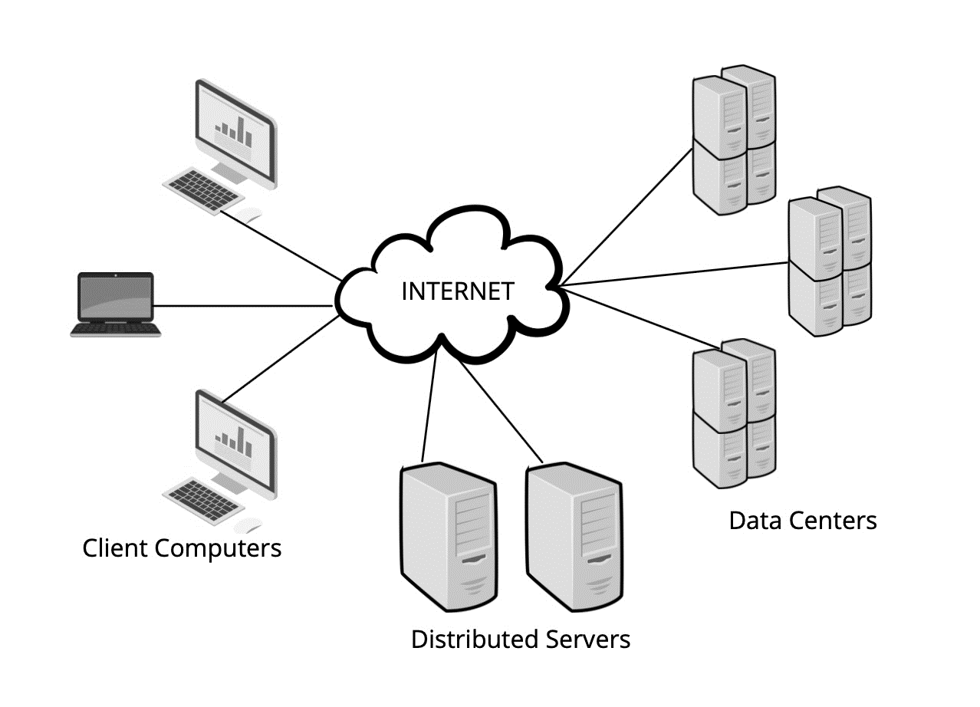

Figure 1. Components of Cloud Computing

1. **SERVICES OF CLOUD COMPUTING**

The services of cloud computing are discussed below:

1. **Infrastructure as a Service (IaaS)**

Cloud computing services are classified in this way. Servers and virtual systems, as well as networks, IT infrastructure, and storage, can all be rented through this service. It eliminates the hassle of acquiring and maintaining one's own physical servers and infrastructure.

1. **Platform as a Service (PaaS)**

This is the only service that provides an on-demand environment for developing, testing, and deploying a variety of software applications. It functions as a server-based cloud deployment platform, allowing for the delivery of both simple cloud applications and sophisticated business applications.

1. **Software as a Service (SaaS)**

This is a method of delivering software applications over the Internet, which can be done on-demand or via a subscription model. It enables people to connect to the Internet and use cloud-based applications. SaaS provides the benefit of application enhancement and operation at a lower cost.

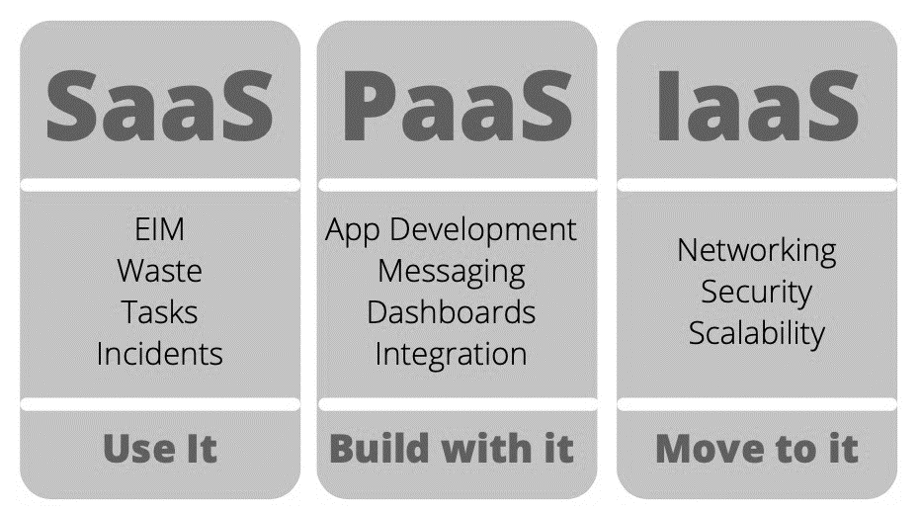

Figure 2. Services of Cloud Computing

1. **COMPARISON OF CLOUD COMPUTING PLATFORMS**

In our Global village, there are various cloud computing platforms; each one has its own

characteristics and advantages (Nawsher Khan., et al., 2011). For better understanding, we analyse these platforms and give comparison from different implementation aspects. Table 1.

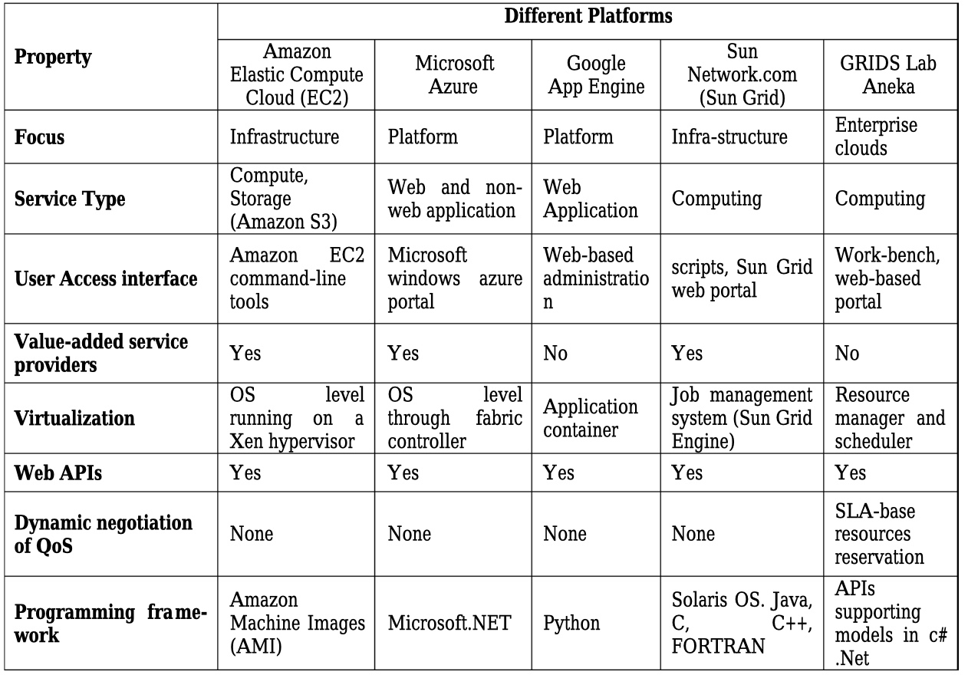

Table 1. Comparison of few cloud computing platforms

We have different kinds of cloud platforms; each one has its own characteristics and advantages. For better understanding, we analyse and give with detail comparison from different implementation aspects. As shown in Table 2.

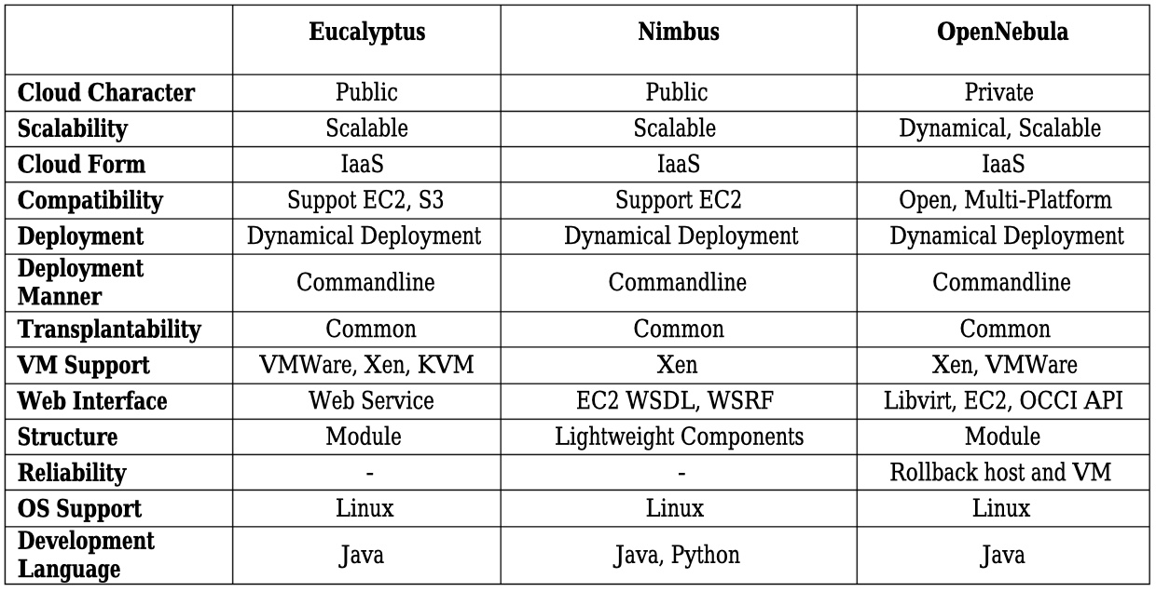

Table 2. Comparison of Cloud computing Platforms on basis of implantation aspects

1. **CONCLUSIONS**

After water, electricity, gas, and telecommunications, cloud computing is the most viable model for delivering IT services as computing utilities. This study provides a thorough examination of several features of cloud platforms. We discovered that there are significant philosophical differences between these various open-source cloud computing frameworks when we looked at the general scheme of their architecture. Following this analysis, the user will have a better understanding of the characteristics and will be able to make better cloud platform, implementation, and deployment decisions.

We still face issues in the cloud, such as continuous availability, data security, and privacy. In today's cloud world, users have no way of knowing what is happening with their data, and it's possible that someone is misusing it. The domains of data replication and data scheduling in cloud computing, as well as the integration of these two replication and scheduling techniques, will be the focus of our future research.

1. **REFERENCES**
2. Khan, Nawsher & Ahmad, Noraziah & Ismail, Elrasheed & Mat Deris, Mustafa. (2011). Cloud Computing: Analysis of Various Platforms.
3. Srivastava, Priyanshu & Khan, Rizwan. (2018). A Review Paper on Cloud Computing. International Journal of Advanced Research in Computer Science and Software Engineering. 8. 17. 10.23956/ijarcsse.v8i6.711.
4. Dr. Mohammed A. T. AlSudiari and Dr. TGK Vasista.(2012). Cloud Computing and Privacy Regulations: an exploratory study on issues and implications. Advanced Computing: An International Journal ( ACIJ ), Vol.3.
5. BV Pranay Kumar, Sumitha kommareddy and N.Uma Rani. (2013). Effective ways Cloud Computing can Contribute to Education Success. Advanced Computing: An International Journal (ACIJ ), Vol.4, No.4,
6. Aakash Tyagi, 2017, A Review Paper on Cloud Computing, INTERNATIONAL JOURNAL OF ENGINEERING RESEARCH & TECHNOLOGY (IJERT) VIMPACT – 2017 (Volume 5 – Issue 23),
7. Brown, I. and Laurie, B. (2000), Security against compelled disclosure In *Computer Security Applications 16th Annual Conference (ACSAC ’00)*. IEEE, New Orleans, LA , USA, Accessed from WWW and Retrieved on 12-03-2012 and Available @ http://www.apache- ssl.org/disclosure.pdf
8. Singh, Dhaneshwar & Madaan, Rosy & Panda, Supriya. (2021). Cloud and mobile computing: the age of virtual internet space. Journal of Physics: Conference Series. 1950. 012013. 10.1088/1742-6596/1950/1/012013.
9. Estamsetty, Venkata. (2021). Cloud Computing, Mobile Cloud Computing and its Comparative Study. 10.13140/RG.2.2.30812.41601.

# Raturi, Saurabh & Verma, Jyoti. (2020). A Survey on Cloud Computing and Security Challenges to Cloud Computing. International Journal of Computer Applications. 175. 29-33. 10.5120/ijca2020920830.